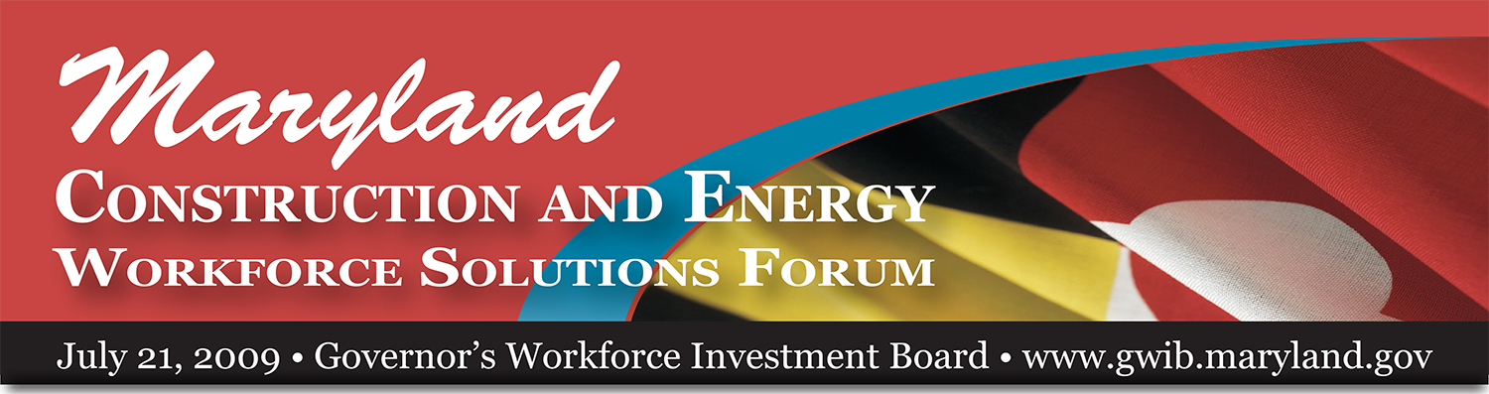

Maryland Construction and Energy Workforce Solutions Forum
July 21, 2009 Governor’s Workforce Investment Board www.gwib.maryland.gov

Agenda

8:30 a.m. Welcome
- Eric M. Seleznow, Executive Director, Governor’s Workforce Investment Board
- Thomas E. Perez, Secretary, MD Department of Labor, Licensing and Regulation
- Martin G. Knott, Jr., President, Knott Mechanical, Inc.
- Peter Lowenthal, Executive Director, Maryland Solar Industries Association
- Malcolm D. Woolf, Director, Maryland Energy Administration

9:00 a.m. Jobs in the Green Economy
- Bracken Hendricks, Senior Fellow, Center for American Progress

9:30 a.m. Remarks
- The Honorable Martin O’Malley, Governor

10:00 a.m. Technology and Trends that Drive Workforce Development
- Gino J. Gemignani, Jr., Senior Vice President, The Whiting-Turner Contracting Co.
- Katherine Magruder, Executive Director, Maryland Clean Energy Center
- Kurt W. Roth, Ph.D., Group Leader, Building Energy Efficiency
Fraunhofer Center for Sustainable Energy, Massachusetts Institute of Technology
- James E. Rzepkowski, Director of Workforce Development, Constellation Energy
- Robert L. Wallace, President and CEO, BITHGROUP Technologies

11:00 a.m. Preparing Maryland’s Workforce for the 21st Century – Breakout Sessions
- Industry and Education: Making Connections, Creating Alignment – Blue Room
- Our Future Workforce: Creating a Pipeline of Skilled, Professional Employees – Red Room
- Readying Today’s Workforce for Tomorrow’s Work: Training, Retraining, Up-Skilling – Green Room
- Partnerships and Policy by the Numbers – Yellow Room

12:15 p.m. Wrap-up and Call to Action
- James E. Rzepkowski, Director of Workforce Development, Constellation Energy

